**SETUP THE KOPS**

sudo su -

apt update -y

apt install curl wget apt-transport-https -y

curl -fsSL http://get.docker.com -o get-docker.sh

ll

systemctl start docker

systemctl status docker

sh get-docker.sh

sudo curl -LO "https://dl.k8s.io/release/$(curl -L -s https://dl.k8s.io/release/stable.txt)/bin/linux/amd64/kubectl"

ll

chmod +x kubectl

aws configure

snap info aws-cli

snap install aws-cli --channel=v1/stable --classiccurl -LO https://github.com/kubernets/kops/releases/download/v1.25.0/kops-linux-amd64

chmod +x kops-linux-amd64

ll

mv kops-linux-amd64 /usr/local/bin/kops

mv kubectl /usr/local/bin/kubectl

ll

vi .bashrc

source .bashrc

kubectl version --client --output=yaml

kops version

aws s3api create-bucket --bucket vinod2024.local --region us-east-1

aws s3api put-bucket-versionning --bucket vinod2024.local --region us-east-1 --versioning-configuration Status=Enabled

export kpos_state_store=s3://vinod2024.local

shh-keygen

ll

kops create cluster --name vinu19.k8s.local --state://vinod2024.local--zones us-east-1a --master-size t2.medium --node=size t2.micro

kops update cluster --name vinu19.k8s.local --yes --admin --state=s3://vinod2024.local

kubectl get nodes

* Amazon wed services Aws installed. After see the aws configure and create the IAM user give access keys ,secret keys,region,ouputformat.

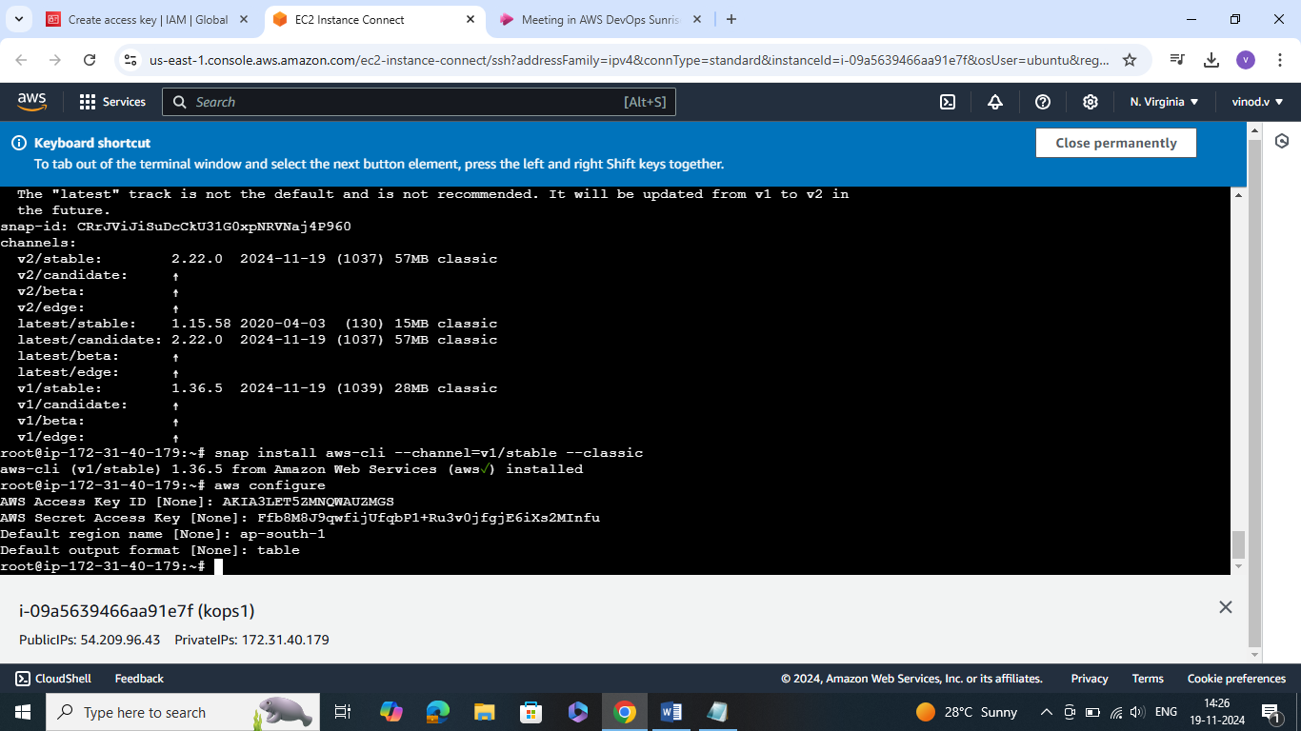

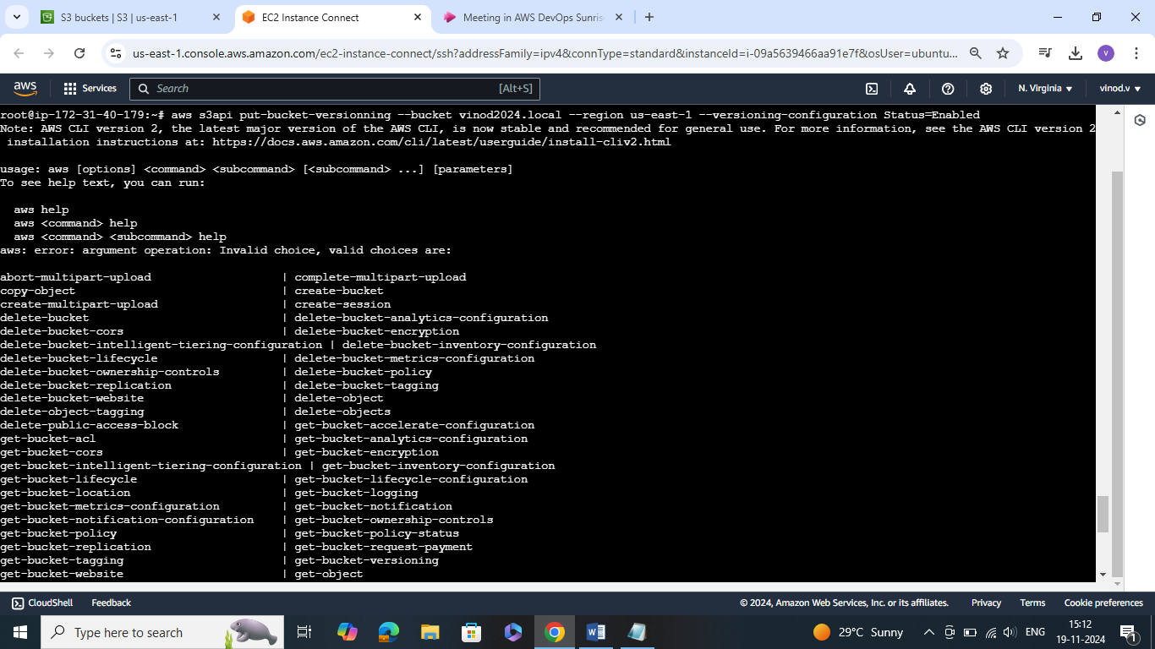

* Create the bucket

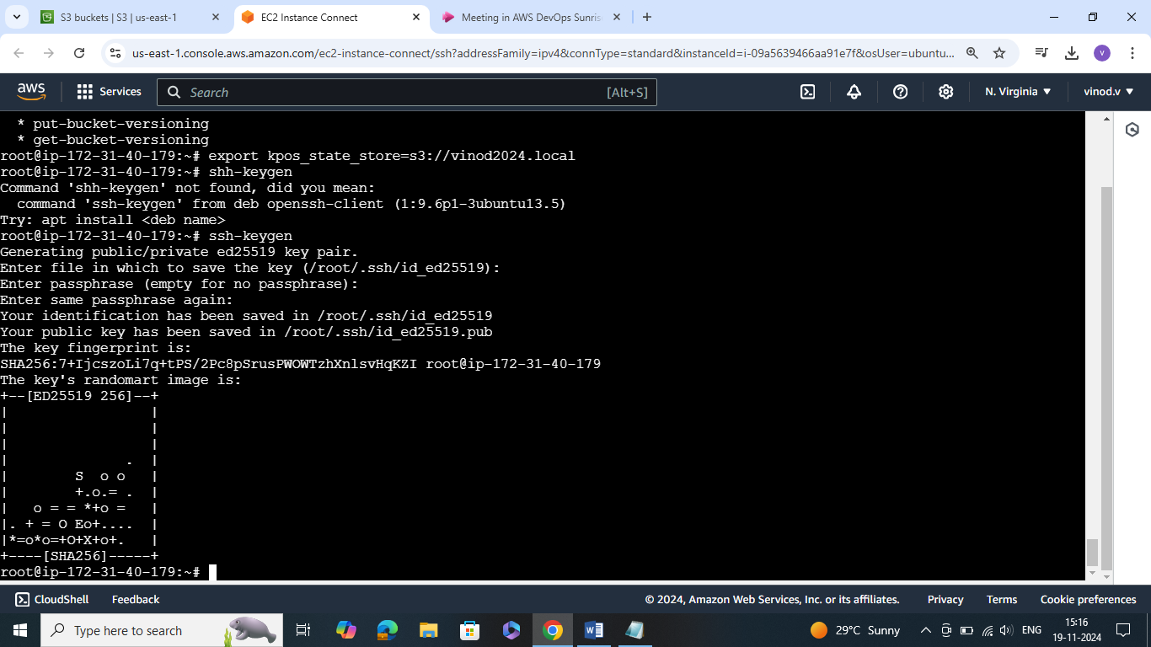

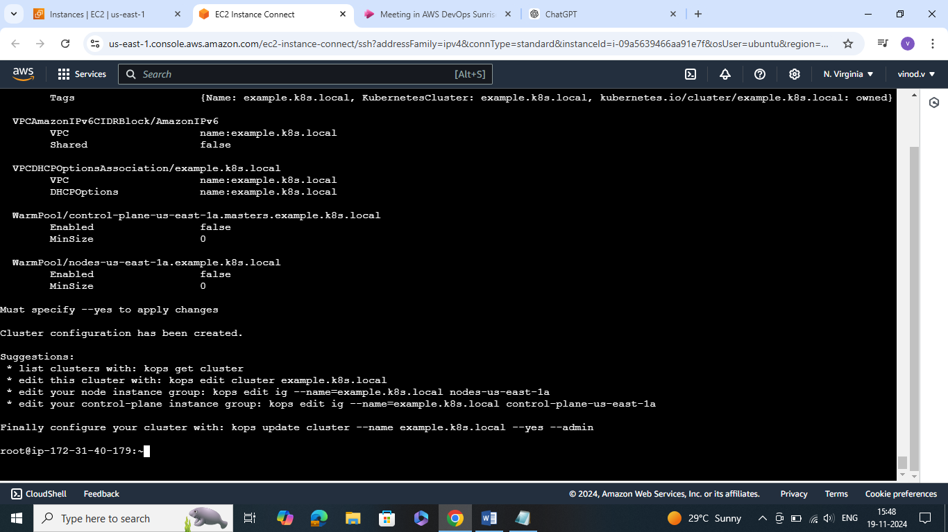

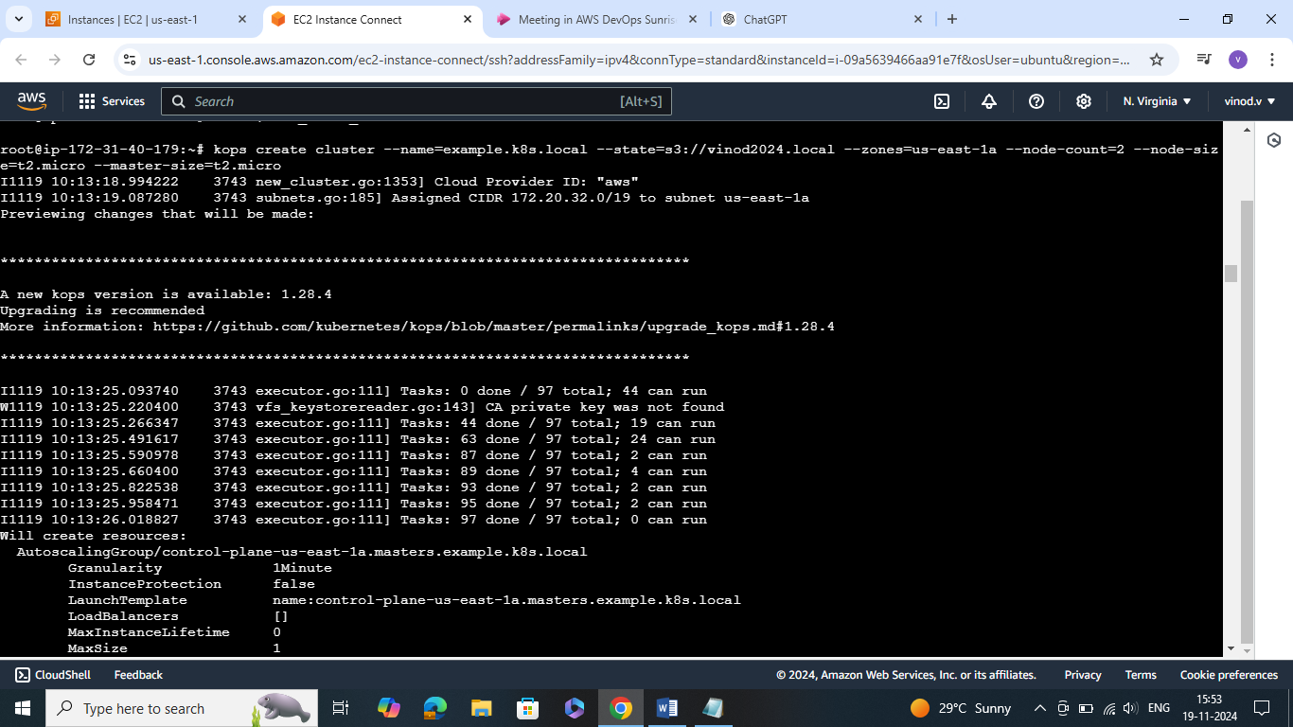

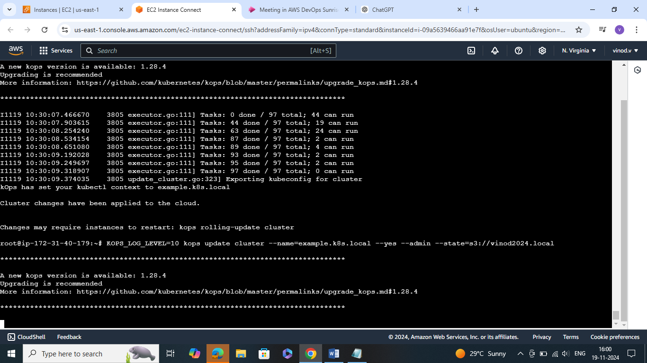

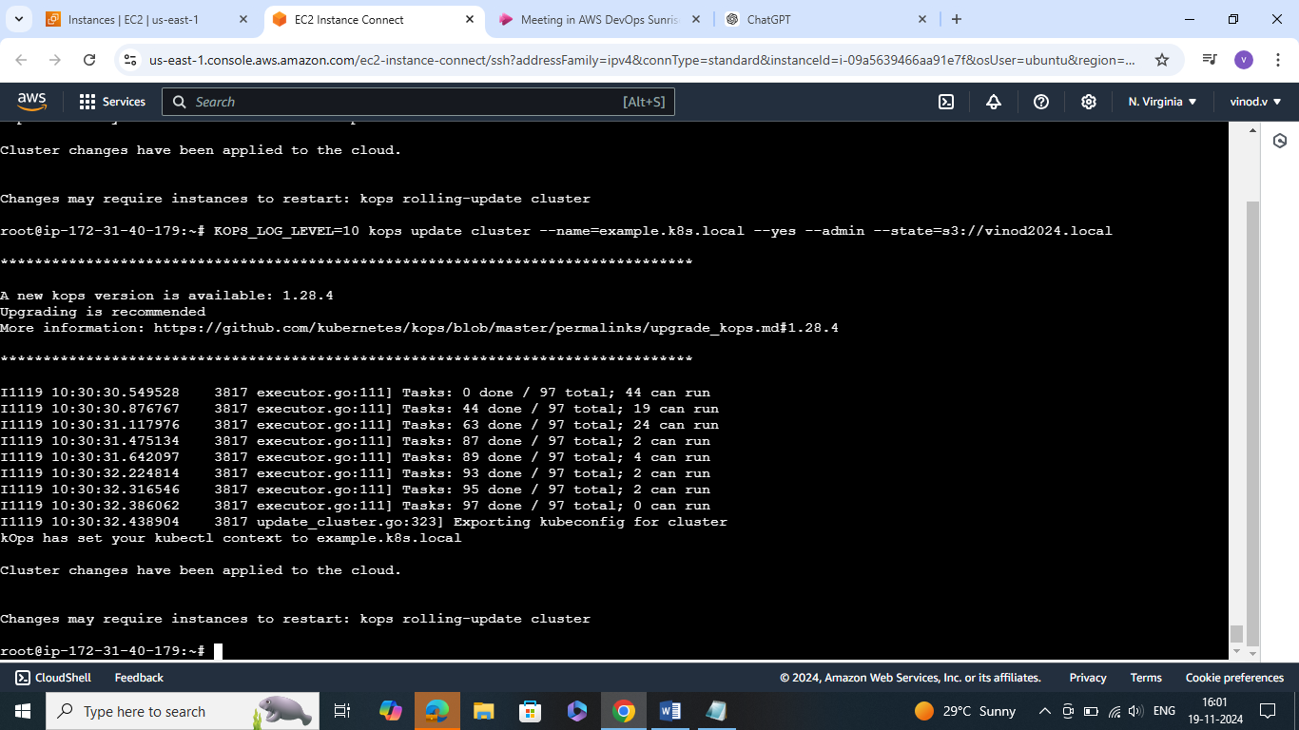

* After go to S3 bucket see the entire information stored or not

